LINDE Workplace Interior
  - DECISION REVIEW · AREQUIPA, PERU (APPROXIMATE CONTEXT) · 9 OCTOBER 2026

Executive view
This Decision pack brings the accepted R4B architectural views and web model, R08 conceptual investment allowance, R09 planning issue, four selected stills and the 44-second editorial film into one review package. It supports a decision about whether to proceed to measured validation and close the open scope before procurement. It does not establish a measured site, certified capacity, an all-in construction budget or authorization to build.

Decision for review
Should the next step be measured validation and scope closure before procurement?
This review supports that discussion; it does not authorize procurement or construction.

Project brief
The concept describes 13 named workplace, meeting, training, reception and support spaces in an approximate Arequipa context. The architectural schedule totals 415.155 m² of plan-area proxies; the R08 estimate uses 415.157 m², a 0.002 m² displayed proxy-total difference. The estimate also uses 463.855 m² as an envelope proxy. None is a measured survey or certified takeoff. No verified address, field survey, certified room capacity or accessibility/code determination is included.

Proposal and current geometry
One schematic interior refresh connects welcome, work, collaboration, training, shared amenity and support spaces through warm oak, pale mineral surfaces, graphite details and restrained blue accents. The accepted plan, axonometric and web GLB show this same proposal within their stated scopes.
The accepted R4B package presents one schematic interior proposal through its plan, axonometric, web model and supporting architectural files. Each file keeps the scope stated in its handoff; the native geometry formats do not all represent the furnished R4B interior. Dimensions, areas, clearances, finishes and site context remain indicative and require field confirmation before design or procurement decisions.
The DWG, BLEND, GLB, IFC and RVT files in the BASE_GEOMETRY folder are geometric context references. They do not represent the current R4B furnished interior. Use CURRENT_R4B for the present conceptual layout, furniture and fixture schedule. The formats have distinct scopes; the current Blender file is an editable mesh model, not a parametric BIM model, and the S04 DXF is an overlay only.

Approved plan and axonometric
Both views show the same R4B schematic proposal. Use the full-size architectural plan in the package for drawing detail; neither view certifies field conditions or construction readiness.
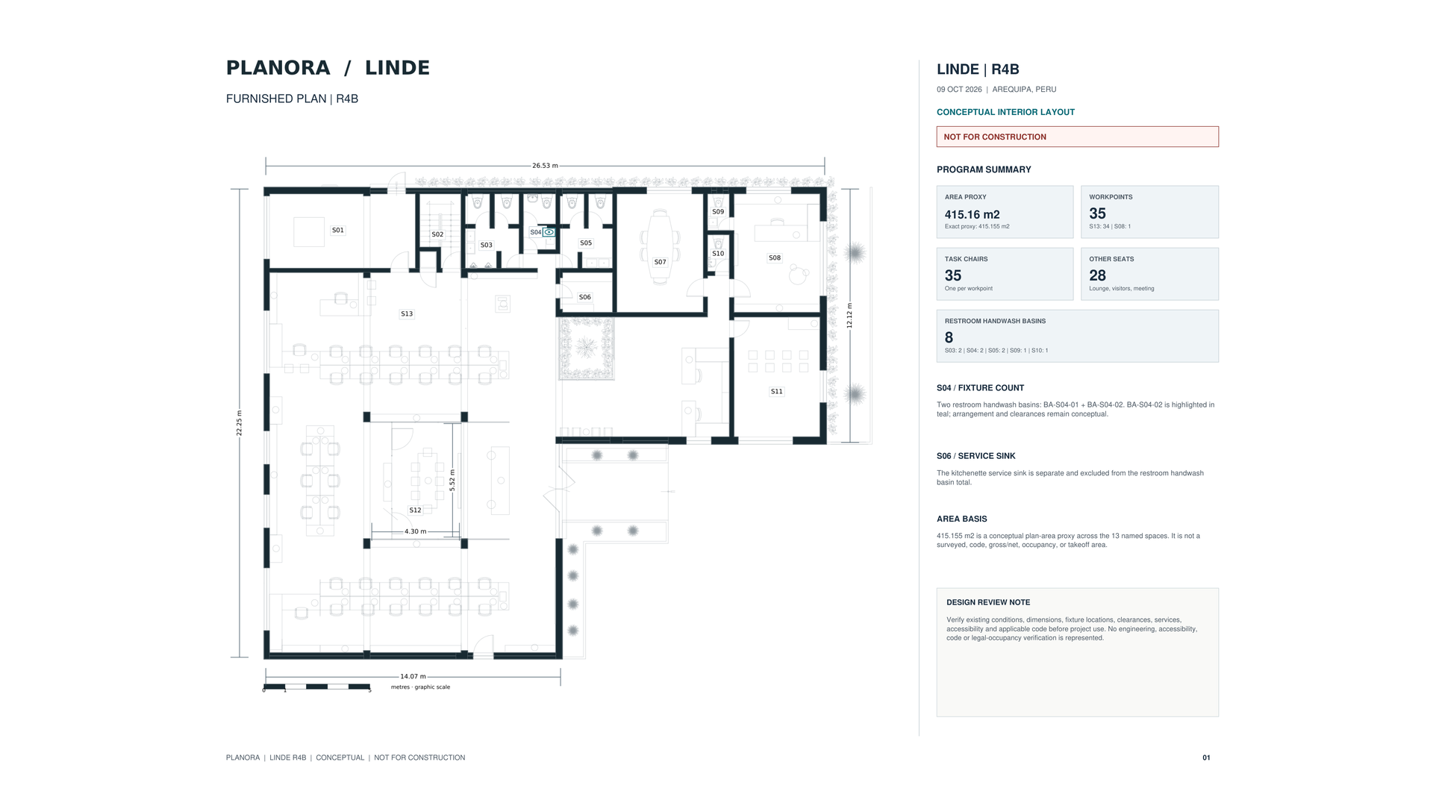  Approved schematic plan · preview | 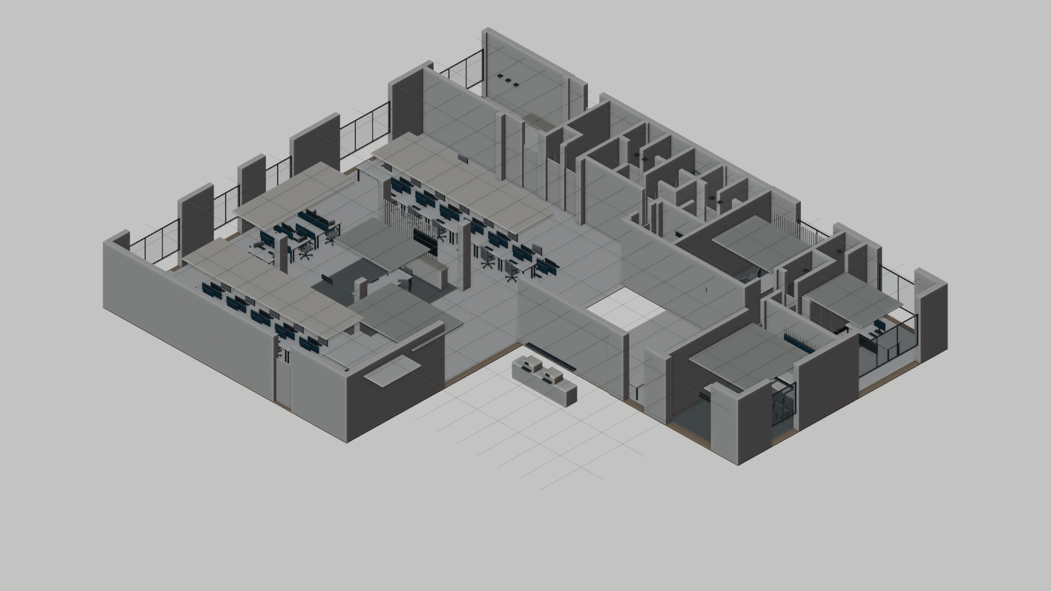  Approved axonometric · conceptual view

Experience and editorial media
These four selected stills remain the visual concept set for discussion. Captions describe design intent; they do not certify dimensions, occupancy or selected products.
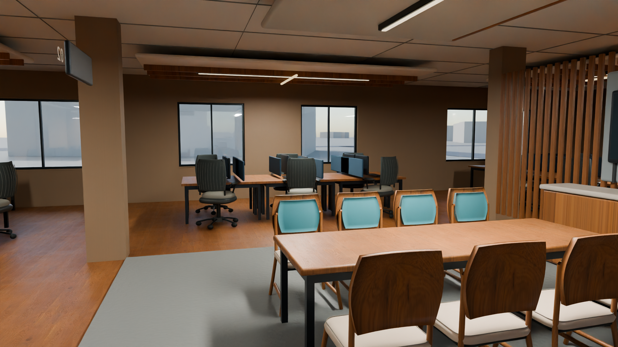  Open office. Workpoints and a shared table communicate design intent, not occupancy or measured fit. | 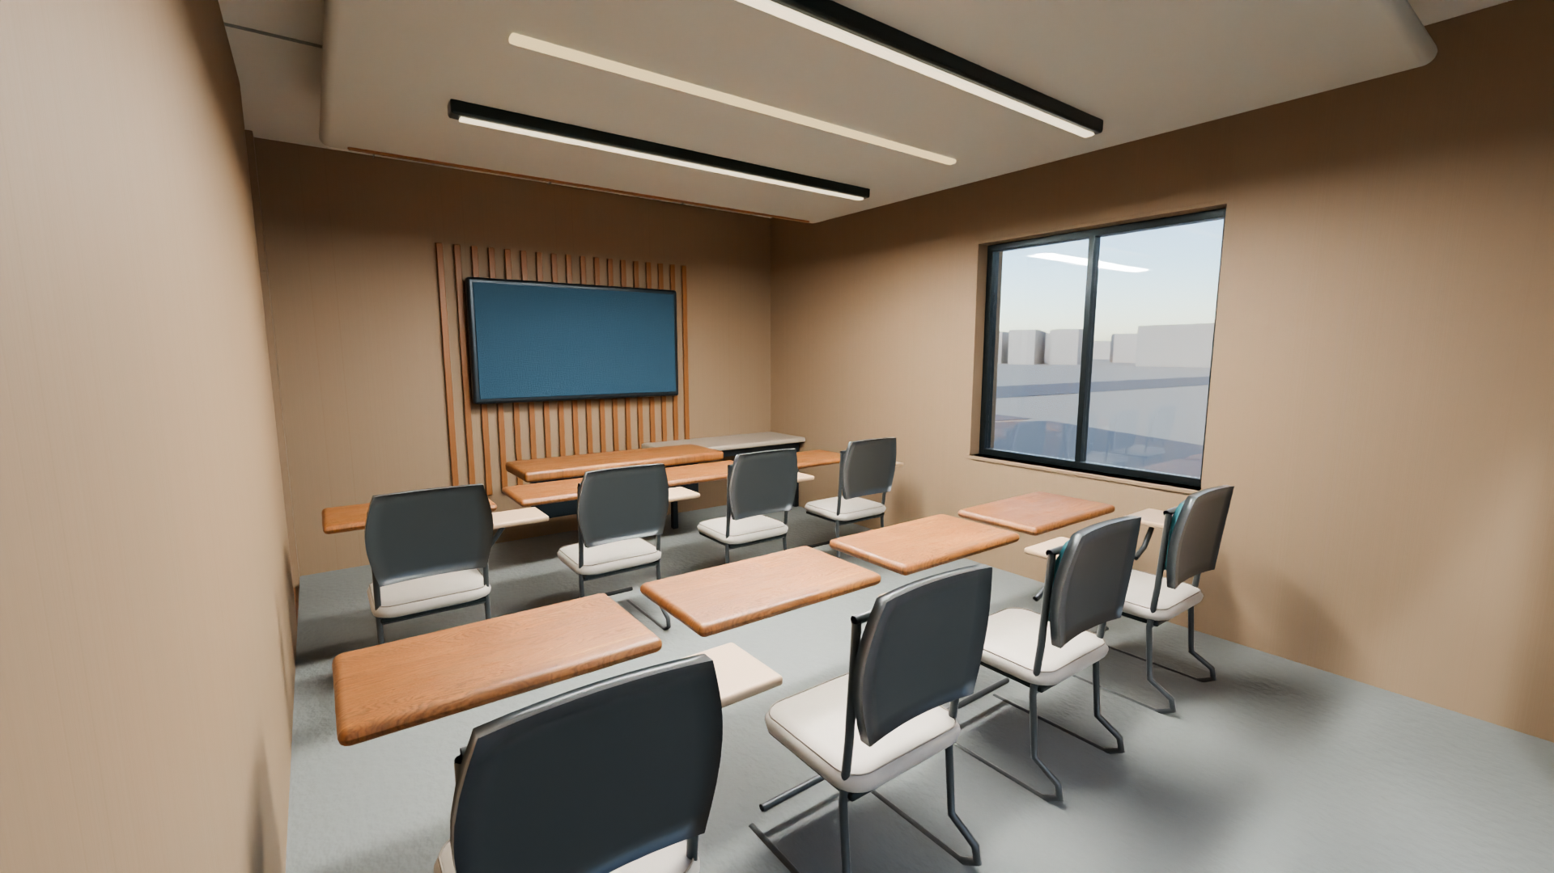  Training room. Furniture arrangement is conceptual; capacity and accessible clearances are not certified.
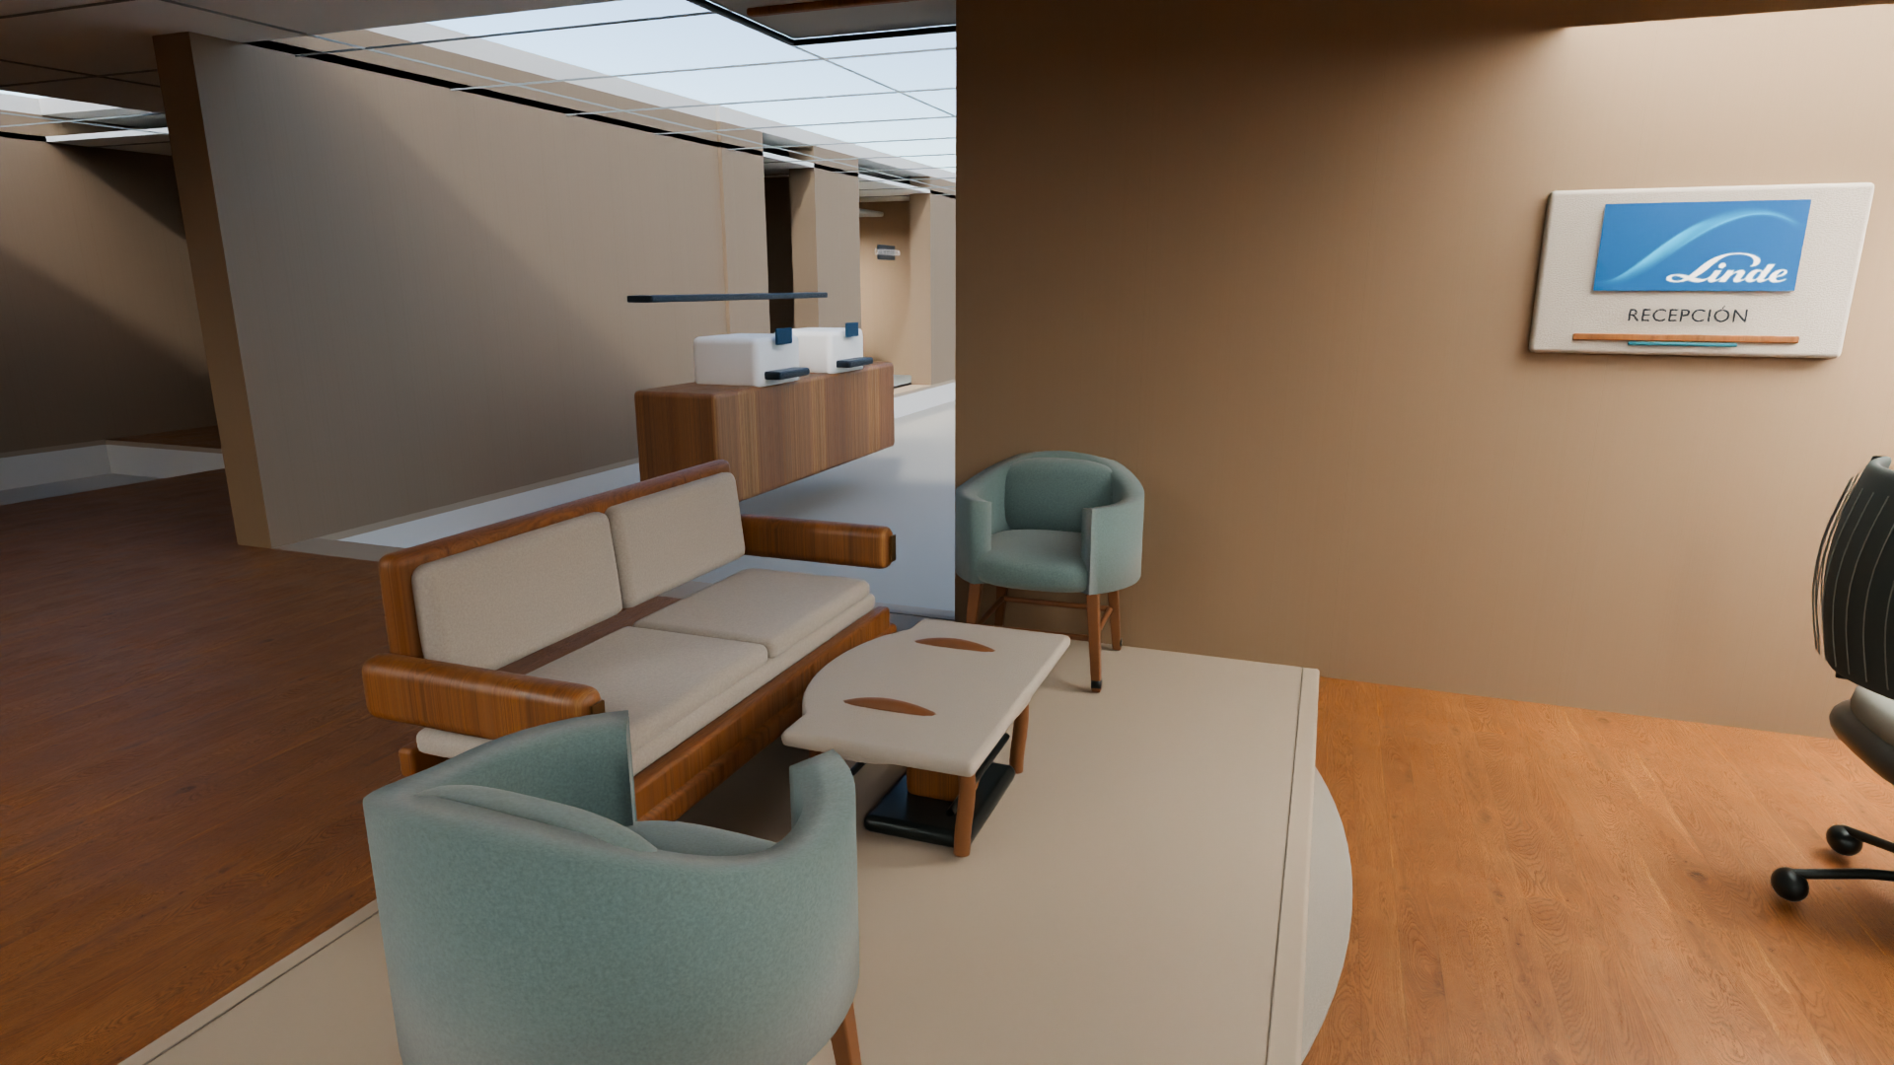  Shared lounge. Finish and furniture cues are visual direction, not product selections. | 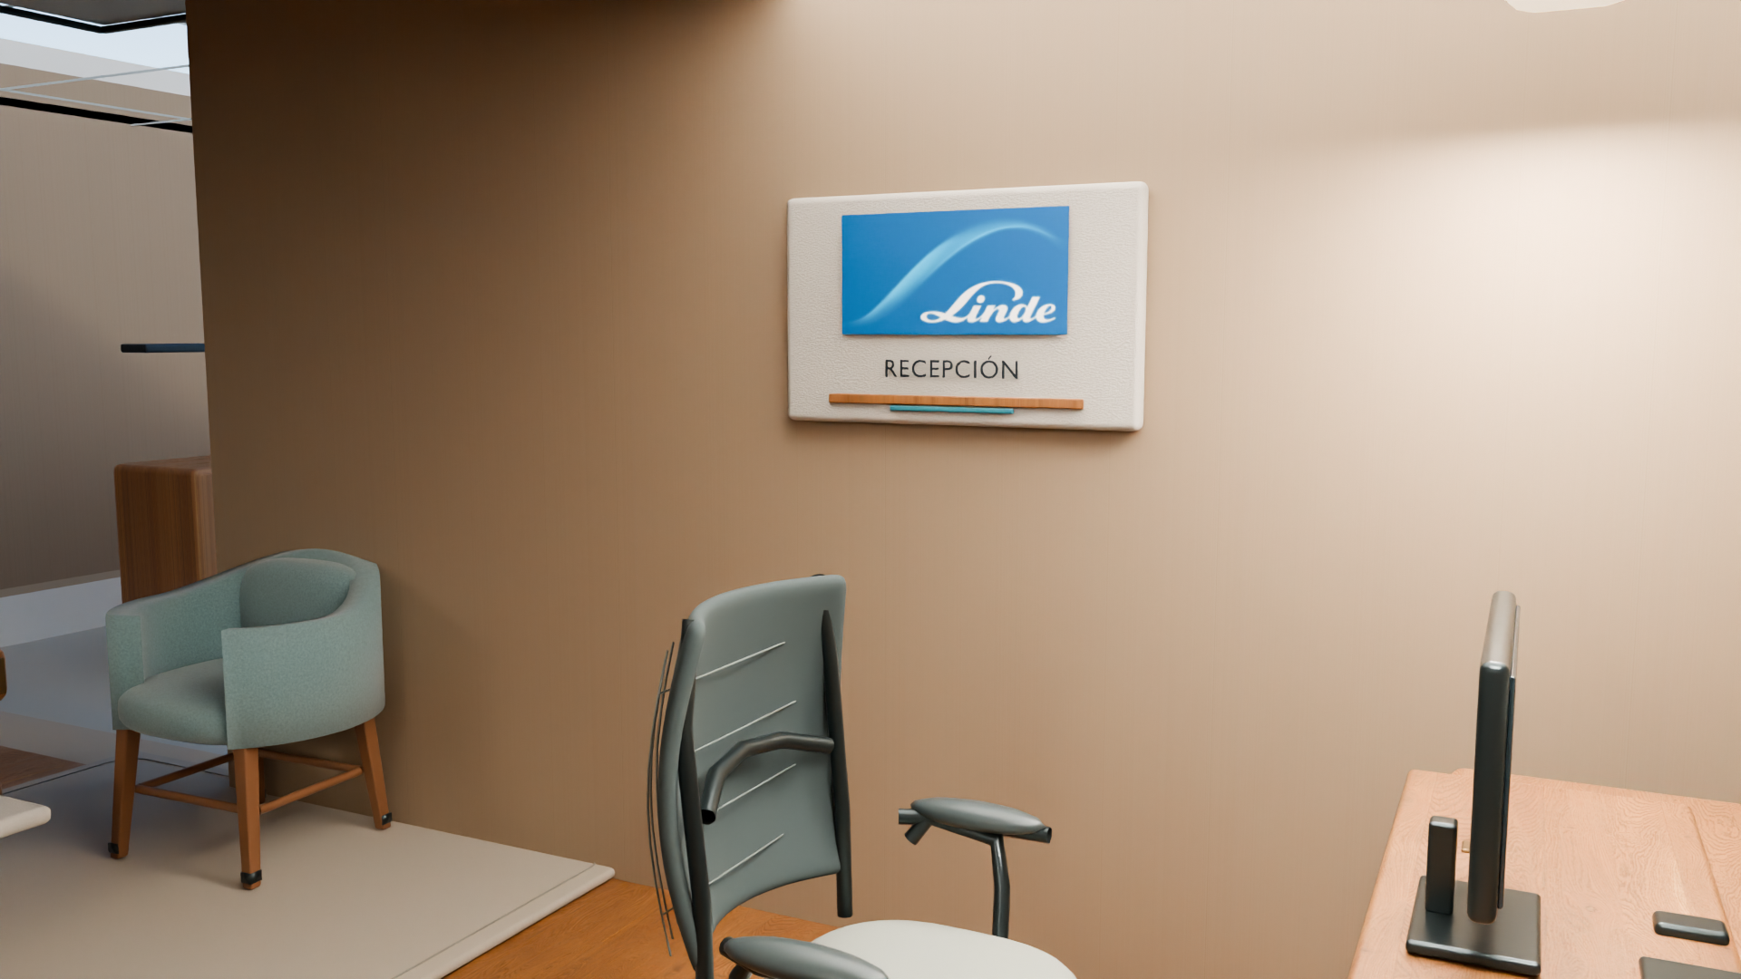  Reception detail. The existing still retains the modeled Spanish spelling on the identity panel.

Film and model are separate assets
The four selected stills and 44-second English film are retained as editorial concept media. The film uses motion over stills; it is not a continuous 3D walkthrough or a new R4B model export. The architectural plan, axonometric, web GLB and native support files are supplied as distinct deliverables.

Decision analysis: fit and quantity basis
The architectural schedule records 415.155 m² of plan-area proxies; the R08 estimate uses 415.157 m², a 0.002 m² displayed proxy-total difference. The estimate also records 463.855 m² as an envelope proxy; none is surveyed. The working floor allowances are 394.77 m² floating SPC and 20.39 m² bathroom tile, plus separate material overage. Other illustrative allowances include 64 surface/ceiling panels, 34 new Cat6A workstation drops plus one assumed existing S08 connection, 30 m cold-water route and 18 m drainage route. These are estimate assumptions, not measured or procurement quantities. The current R4B Electrical and Data addendum establishes no device quantity delta; no zero delta is declared.
R4B represents 35 workpoints and task-chair positions: 34 in S13 and one in S08. The R08 allowance covers 34 new S13 task chairs and 34 new Cat6A drops; one S08 task chair and its existing data connection are assumed retained and reused, subject to field verification. The S08 management desk remains new supply within the existing two-desk allowance, alongside the S13 desk; the two S08 visitor chairs are separate. The 28 other seats are covered by existing allowances. If the task chair or data connection cannot be reused, a future separately priced scope revision is required. This addendum changes no model quantity, assembly, resource, rate or cost item.
The cost package has 69 estimate assemblies and 146 resources. Those are estimate organization counts; they do not validate installed quantities. No certified capacity, field dimension or code/clearance result is established.
Estimate proxy / allowance | Value and status
Area proxies | 415.155 m² architecture · 415.157 m² estimate; 0.002 m² proxy difference
Floor | 394.77 m² SPC · 20.39 m² tile; allowances
Lighting / data | 64 panels · 34 new Cat6A drops + 1 assumed existing S08 connection
Workpoints / task chairs | 35 represented · 34 new S13 + 1 S08 reused, subject to field check
Plumbing routes | 30 m cold water · 18 m drainage; not measured
Estimate structure | 69 line items · 146 resources; not field-verified quantities

R4B change and coordination limits
The plan, axonometric, web GLB and native support files are distinct deliverables with the scope and limitations stated in their supplied handoff. They support conceptual review and do not establish surveyed dimensions, code compliance, engineering approval or construction readiness.
The web model is for conceptual review and visual coordination only. Nearby roads, buildings and ground are simplified orientation context, not survey or property-boundary information. Dimensions, areas, fixture clearances and finishes are indicative. The model does not verify code, life-safety, accessibility, structural, mechanical, electrical or plumbing compliance; it is not for construction, permitting, procurement, fabrication or installation.
The accompanying model handoff supplies OpenStreetMap attribution. The five geometric base references are separate from the furnished R4B concept and are not current interior deliverables.

R4B discipline notes
The following issued notes support limited conceptual communication. Electrical and Mechanical D4.2 base issues remain unchanged and are paired with their R4B addenda. Sanitary and Hydraulic D3.6 is the current note.

Electrical and Data
D4.2 remains unchanged. The R4B addendum establishes no R4B-specific Electrical and Data quantity delta; no zero delta is declared. Point reconciliation, circuits, loads, routes, AC-01, luminaire interfaces and data endpoints remain unverified.
The R08 basis carries estimate allowances for lighting and data; those allowances are not an R4B point takeoff. See the current addendum for open interfaces and required inputs.

Mechanical and HVAC
D4.2 remains unchanged. The R4B additive review updates selected architectural coordination evidence but closes no HVAC design decision. M01–M12 remain open technical scope items for any later design or construction work; their status limits technical claims but does not prevent review of this schematic concept. Its D3.5 sanitary reference is historical; Sanitary D3.6 is the current note.

Sanitary and Hydraulic
D3.6 is the current limited conceptual note. It proposes two basin stations and one water closet in S04. Its physical assignment, services, support, clearances, accessibility, code and performance remain unverified.
Sanitary D3.6 proposes moving one retained basin station from the S13/open-office area to S04. The room schedule lists eight restroom basins versus seven in the earlier concept; the change is a reassignment, not an added purchase. Separately, the accepted cost addendum reconciles the estimate to six new basins plus two existing S04 basins retained and rehosted. The S06 kitchenette service sink is separate. Services, support, usable clearances and field conditions remain to be verified.

Structural and Civil
The current conceptual model represents nine exterior openings with dimensions for both the modeled openings and the clear glazing. Jamb, head, sill and frame elements are shown separately in the model. These observations describe model geometry only; they do not verify field dimensions, structural support, anchorage, glazing performance, code compliance or construction readiness. No procurement quantity is established.
The corresponding limited conceptual source notes are available in the technical folder and from the review portal. These notes do not approve engineering design or procurement.

Investment
REPORTED BASE  USD 75,304.53 | SAME-DESIGN SENSITIVITY  USD 55,869.25–107,520.39
The sensitivity varies provisional quantities, supplier comparators, productivity and reserve assumptions. It is not a probability interval and does not represent alternative designs.

Reported components
Component | USD
Priced direct scope | 61,669.85
Contractor overhead and profit on eligible installation work | 3,977.82
Modeled labor/contractor-fee IGV allowance | 1,588.51
Owner design-development reserve | 8,068.34
The reported base uses unrounded inputs. The displayed component amounts sum to USD 75,304.52; the USD 0.01 difference is rounding, not an added or omitted scope line.
Estimate basis: 798.38 budget person-hours. This is not R09’s 960 schedule-duration hours, a crew count or a validated construction duration. The public R08 basis and eight unchanged cost workbooks are supplied with this package.
Two consolidated freight allowances totaling USD 1,048.03 are already included in the base. No separate time-based premium, weekly site-management, standby, financing or escalation amount is supported. R09 tasks, durations and resources are unchanged.

Assumptions and exclusions
The estimate is a conceptual investment allowance for one assumed refresh, not a contractor quotation, measured bill of quantities, construction drawing or all-in budget. Field verify existing conditions, access, routes, support and finish selections before procurement.

Not included
- Licensed off-site haul/disposal fees for removed parquet and tile; debris classification and local Arequipa fee are not established.
- Structural or major slab/substrate repairs; wall or ceiling reconstruction beyond stated allowances.
- New main electrical panels, feeders or capacity upgrades; fire alarm, sprinkler or other life-safety modifications.
- Core network, firewall, Wi-Fi, PoE/UPS, AV and access control.
- Full window, glazing or door replacement; repair/maintenance of uncounted retained HVAC equipment beyond interface checks.
- Existing-condition and MEP capacity surveys; architectural/MEP design coordination and professional certification.
- Authorization and submission fees; taxes on unpriced future taxable packages.
- Retained timber furniture and frame-trim refurbishment, including R09 UID 76; its condition, quantity and repair standard are unpriced.
- Decorative linear/wall-wash fixtures without a measured fixture schedule.
- Staff relocation/storage, temporary office, financing and schedule acceleration.
- Other field-dependent repairs or scope beyond the assumptions stated in the attached public R08 basis. Excluded items are unpriced, not zero-cost.
The attached public ESTIMATE_BASIS_R08_EN.md contains the full coverage assumptions, scope notes and decision-use conditions. Excluded items have no assigned zero cost.

Program and dependencies
R09 is illustrative: 5 October 2026 start, 19 March 2027 calculated finish and 960 schedule-duration hours (120 assumed eight-hour working days). These are not person-hours or a contractual duration. The estimate has 798.38 budget person-hours; R09 has no crew assignments, resource capacity, actual progress or resource leveling.
Supply targets and staged-work dates in R09 are planning assumptions, not confirmed supplier promises or an approved baseline. Two consolidated freight allowances are in the cost base. The current schedule PDF, XML and basis note are included unchanged.

Before any purchase or contract
- Measure areas, rooms, existing conditions, access, support and MEP routes; reconcile the quantity basis.
- Resolve the S04 basin move, plumbing and usable clearances; confirm life-safety/accessibility and engineering requirements with responsible professionals.
- Obtain licensed disposal pricing, confirm supplier availability and selections, and reconcile taxable contract packages.
- Only after scope and quantities are verified, decide whether to seek a contractor quotation and an approved construction baseline.

Package contents
This issue includes editable and PDF versions of the report, 19-slide Decision presentation and review guide; accepted architectural plan, axonometric, native support files and nested architecture archive; reviewed discipline notes; eight unchanged R08 XLS workbooks and public basis; accepted R09 PDF/XML/basis; four selected stills; the 44-second film; and an interactive review portal. Each architectural file retains the scope stated in its handoff.
Not for construction. No permit/seal. Schematic only.

